TEAM 2008, Oct. 6-9, 2008, Istanbul, Turkey

Allowable pages: 4~8 pages

Title [Times new roman, 18 size, bold]
Presenter*, Co-author [Times new roman, 12 size, normal]
Title and Full Address [Times new roman, 12 size, italic]
e-mail: xx@xx.com [Times new roman, 12 size, normal]

Abstract [Times new roman, 12 size, bold]
abstract within 150 words. [Times new roman, 11 size, normal]

Keyword: Less than 6 keywords. [Times new roman, 11 size, normal]

1. Section 1 [Times new roman, 12 size, bold]

Subtitle 1 [Times new roman, 12 size, bold italic]

[all contents, Times new roman, 11 size, normal]
For the implicit representation of structural boundaries, we employ a level set method that describes a boundary in implicit form as the iso-surface of a scalar function, $φ:R^{3}→R$, embedded in three dimensional space. The boundary Γ is stated as
$Γ=\left\{x:φ(x,0)=k\right\}$, (1)
where k and x are an arbitrary iso-value and a point on the iso-surface $φ$, respectively.

Table 1. Comparison of design sensitivity
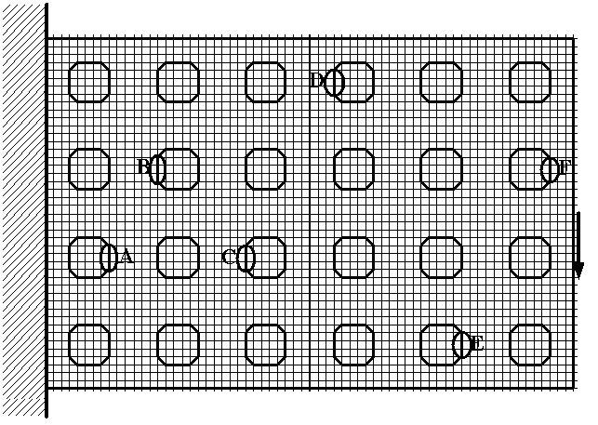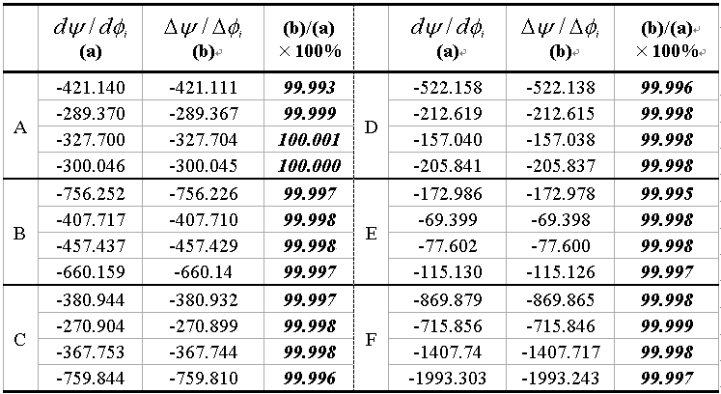
Fig. 2 Cantilever plate

Conclusions [Times new roman, 12 size, bold]

Acknowledgements [Times new roman, 12 size, bold]

REFERENCES [Times new roman, 12 size, bold]

- J.A. Sethian, Level Set Methods and Fast Marching Methods: Evolving interfaces in computational geometry, fluid mechanics, computer vision, and materials science, Cambridge University Press, (1999).
- Cho S, Jung H., Design sensitivity analysis and topology optimization of displacement-loaded nonlinear structures, Computer Methods in Applied Mechanics and Engineering, 192, (2003), 2539-2553.

